Real Estate Redevelopment
& Reuse
Sponsored By:
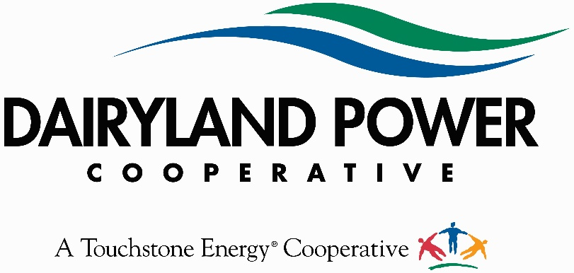
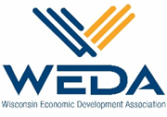
WEDA’S Community & Economic Development Awards
ABOUT THE AWARDS:
This is an excellent opportunity to recognize individuals, businesses, projects and organizations that are making significant contributions to the economy of Wisconsin. It is also a good way to spotlight best practices in Community & Economic Development and the important role each play in growing our economy. Awards winners will be featured in publications and press releases across Wisconsin.
SELECTION PROCESS:
An impartial panel of partners, sponsors and WEDA members will screen the nominations to ensure that they are complete and appropriate. The judges will independently score each nomination. The WEDA staff will tabulate the scores to determine the finalists and award-winning nominations. The judges scoring and rankings will determine the winners in each category.
APPLICATION DEADLINE: Noon on July 8 2021. No late nominations will be considered. All applications are to be filled out online and submitted electronically to weda@weda.org
AWARDS CEREMONY:
The ceremony will be the evening of September 15th, 2021 at The Edgewater Hotel in Madison. All nominees and their nominators are encouraged to register and attend!

WEDA’s Community & Economic Development Award - Partners:

Real Estate Redevelopment & Reuse Award
This award recognizes innovative real estate redevelopment or reuse projects that demonstrate measurable and quantitative impact on employment and tax base. Nominations should provide details as to why the project will/has served as a catalyst for economic and community development efforts. It should also demonstrate an innovative approach to development and should have been completed within the past 5 years.
If you have any questions, please contact WEDA staff:

Mary Perry
President and Chief Executive Officer
Wisconsin Economic Development Association
(608) 255-5666
mperry@weda.org

Final Nominations are to be submitted to: weda@weda.org

Organization Nominated: Click or tap here to enter text.
Organization Contact Name Click or tap here to enter text.
Address: Click or tap here to enter text.
City / State / Zip: Click or tap here to enter text.
Phone: Click or tap here to enter text. Email: Click or tap here to enter text.

Nominator Name: Click or tap here to enter text.
Company Name:
Address: Click or tap here to enter text.
City / State / Zip: Click or tap here to enter text.
Phone: Click or tap here to enter text. Email: Click or tap here to enter text.

Please list what development tools were used on the project:
☐Tax Incremental Finance District ☐ Historic Tax Credit ☐ New Market Tax Credits
☐ Revolving Loan Fund ☐ WI Fast Forward ☐ WHEDA Loan
☐ USDA ☐ CDBG ☐ Redevelopment Authority
☐ Transportation Economic Assistance ☐ WEDC Tax Credits/Loans☐ WEDC Technical Assistance

Description of Technical Assistance or Other Programs: Click or tap here to enter text.

Summary:
Total Investment: Click or tap here to enter text. Jobs Retained: Click here to enter text.
Private Sector Investment: Click or tap here to enter text. Jobs Created: Click here to enter text.
Public Investment: Click or tap here to enter text. Other Investments: Click or tap here to enter text.
Original Tax Base: Click or tap here to enter text. Current Tax Base: Click or tap here to enter text.

Two Page Nomination Narrative
- Describe the real estate redevelopment and reuse project. Include the former uses of the property, how the redevelopment project came to light and the partnerships and innovative approach used to bring the project to fruition.

- What impact has this redevelopment or reuse project had on the area’s tax base and employment? Describe other quantitative or qualitative benefits.

- Describe how the project has been or will be a catalyst for additional economic and community development efforts?

- Please submit any articles, awards, photos (i.e. before and after) that support your nomination (maximum 7 pages).

