Talent Development Award

Sponsored By:
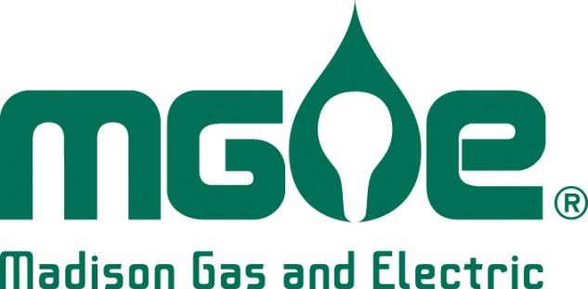

WEDA’S Community & Economic Development Awards

ABOUT THE AWARDS:
This is an excellent opportunity to recognize individuals, businesses, projects and organizations that are making significant contributions to the economy of Wisconsin. It is also a good way to spotlight best practices in Community & Economic Development and the important role each play in growing our economy. Awards winners will be featured in publications and press releases across Wisconsin.
SELECTION PROCESS:
An impartial panel of partners, sponsors and WEDA members will screen the nominations to ensure that they are complete and appropriate. The judges will independently score each nomination. The WEDA staff will tabulate the scores to determine the finalists and award-winning nominations. The judges scoring and rankings will determine the winners in each category.
APPLICATION DEADLINE: Noon on July 20, 2021. No late nominations will be considered. All applications are to be filled out online and submitted electronically to weda@weda.org
AWARDS CEREMONY:
The ceremony will be the evening of September 15th, 2021 at The Edgewater Hotel in Madison. All nominees and their nominators are encouraged to register and attend!

WEDA’s Community & Economic Development Award - Partners:

Talent Development
This award recognizes initiatives or programs that can document successful Talent Development outcomes. Nominations should identify how the program or initiative provided a strategic and innovative approach to meet one or more of following goals: Strengthening the skills of the workforce; Talent attraction and retention; Integration and alignment of economic and workforce development activities; Diversity and inclusion; and Addressing barriers to employment such as childcare, housing and transportation.

If you have any questions, please contact WEDA staff:

Mary Perry
President and Chief Executive Officer
Wisconsin Economic Development Association
(608) 255-5666
mperry@weda.org

Final Nominations are to be submitted to: weda@weda.org

Organization Nominated: Click or tap here to enter text.
Organization Contact Name Click or tap here to enter text.
Address: Click or tap here to enter text.
City / State / Zip: Click or tap here to enter text.
Phone: Click or tap here to enter text. Email: Click or tap here to enter text.

Nominator Name: Click or tap here to enter text.
Company Name: Click or tap here to enter text.
Address: Click or tap here to enter text.
City / State / Zip: Click or tap here to enter text.
Phone: Click or tap here to enter text. Email: Click or tap here to enter text.

Please list what development tools were used on the project:
☐Tax Incremental Finance District ☐ Historic Tax Credit ☐ New Market Tax Credits
☐ Revolving Loan Fund ☐ WI Fast Forward ☐ WHEDA Loan
☐ USDA ☐ CDBG ☐ Redevelopment Authority
☐ Transportation Economic Assistance ☐ WEDC Tax Credits/Loans☐ WEDC Technical Assistance

Description of Technical Assistance or Other Programs: Click or tap here to enter text.

Summary:
Total Investment: Click or tap here to enter text. Jobs Retained: Click here to enter text.
Private Sector Investment: Click or tap here to enter text. Jobs Created: Click here to enter text.
Public Investment: Click or tap here to enter text.

Two Page Nomination Narrative
- Describe the Talent Development initiative or program. Describe the specific factors in your community or region that led to the development of this program.
Click or tap here to enter text.

- Define the quantitative and qualitative metrics set forth as part of this program. Describe the results to date.
Click or tap here to enter text.

- Identify how the program or initiative provides a strategic and innovative approach to meet one or more of following goals:
  - Strengthening the skills of the workforce
  - Talent attraction and retention
  - Integration and alignment of economic and workforce development activities
  - Diversity and Inclusion
  - Addressing barriers to employment such as childcare, housing and transportation
Click or tap here to enter text.

- Please submit any articles, awards, or photos that support your nomination in a pdf (maximum 5 pages).

